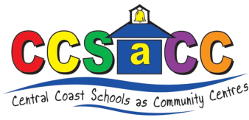
Wyoming Schools as Community Centre
Term 1 2021
Monday
Pram Walkers group
Come join us for a pram walking group around Wyoming. All little ones must stay in the pram for safety reasons. Walk at your pass and chat to other parents whilst we keep each other motivated to get a bit of exercise. 9.15 – 10.30am
Adult craft group
Bring along your current craft project to work on or join us in making some new beaded jewelry. Children are welcome; however, no childcare is provided, simple play activities will be provided for them.
12.30 – 2.00pm

Tuesday
Baby play groups
A play group especially for babies 0-18 months, play in a safe, warm and friendly environment. We play, sing and have fun together. Come along and meet other young families.
10.00 – 11.30am

Little learners
Activities and small group experiences that help build your child’s literacy through learning letters, their sounds and how to write a single letter correctly. For children starting school next year, bookings required.
12.30 - 1.30pm

Wednesday
Supported play group
Fun for all young children, we encourage learning through play. It’s also opportunity for parents to meet, create friendships and become connected to the local community. New families are always welcome.
9.30 – 11.00am

Math’s matter
This group aim is to develop essential early math skills for your Preschooler. Concepts are taught through an engaging collection of hands on learning activities. For children starting school next year only.
12.00 - 1.00pm.

Thursday
Kids on the move
This group focuses upon developing motor skills through play. Enhancing skills such as ball control, jumping and balancing, whilst having a whole lot of fun. 2-3 yrs 9.20 - 9.50am 3-5 yrs 10.00 - 10.40am

All groups are run to strict COVID safe guidelines, numbers are limited, and hygiene practices enforced. Booking are required for every group.
For further inquiries/ bookings contact: Lynda on 0436 928 606.
Visit our website www.ccsacc.org or like us on Facebook.

